

Date: 21-Dec-18

Submitted by: Umair Ayaz Aslam

Submitted to: Ms Laila Khalid

Reg No: 2018484

Course: CS121

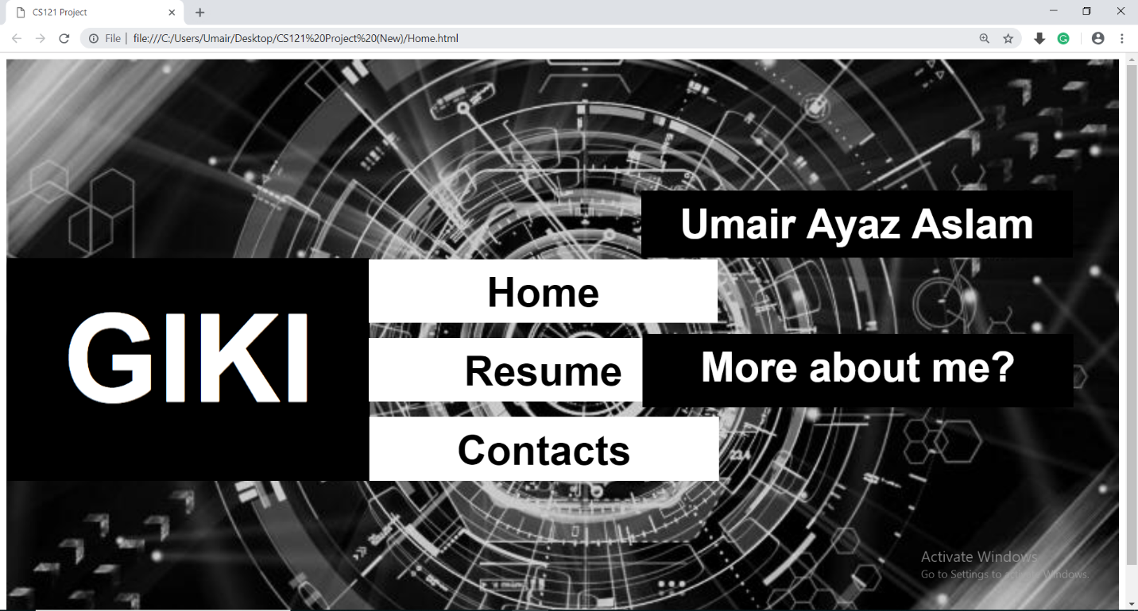**\*I have used HTML and Microsoft Expression Web 4 for creating webpages\***

**Codes:**

**HTML**

**Home:**

<!doctype html>

<html>

<head>

<meta charset="utf-8">

<title>CS121 Priject</title>

</head>

<img src="Background.jpg" width="100%" height="100%" alt=""/>

<h2 style="background-color: #000; border-color: #000; padding: 0.25em; position: absolute; text-align: center; top: 128px; left: 9px; width: 370px; height: 198px; font-family: Gotham, 'Helvetica Neue', Helvetica, Arial, sans-serif; color: #FFF; text-shadow: 0px 1px 0px rgba(255,255,255,.5); font-size: 150px">GIKI</h2>

<h2 style="background-color: #000; border-color: #000; padding: 0.25em; position: absolute; text-align: center; top: 128px; left: 787px; width: 504px; height: 57px; font-family: Gotham, 'Helvetica Neue', Helvetica, Arial, sans-serif; color: #FFF; text-shadow: 0px 1px 0px rgba(255,255,255,.5); font-size: 50px">Umair Ayaz Aslam</h2>

<a href="Home.html"><h2 style="background-color: #FFF; border-color: #FFF; padding: 0.25em; position: absolute; text-align: center; top: 212px; left: 452px; width: 404px; height: 53px; font-family: Gotham, 'Helvetica Neue', Helvetica, Arial, sans-serif; color: #000; text-shadow: 0px 1px 0px rgba(255,255,255,.5); font-size: 50px">Home</h2></a>

<a href="Resume.html"><h2 style="background-color: #FFF; border-color: #FFF; padding: 0.25em; position: absolute; text-align: center; top: 309px; left: 452px; width: 404px; height: 53px; font-family: Gotham, 'Helvetica Neue', Helvetica, Arial, sans-serif; color: #000; text-shadow: 0px 1px 0px rgba(255,255,255,.5); font-size: 50px">Resume</h2></a>

<a href="Contact.html"><h2 style="background-color: #FFF; border-color: #FFF; padding: 0.25em; position: absolute; text-align: center; top: 406px; left: 453px; width: 404px; height: 53px; font-family: Gotham, 'Helvetica Neue', Helvetica, Arial, sans-serif; color: #000; text-shadow: 0px 1px 0px rgba(255,255,255,.5); font-size: 50px">Contacts</h2></a>

<h2 style="background-color: #000; border-color: #000; padding: 0.25em; position: absolute; text-align: center; top: 304px; left: 788px; width: 504px; height: 65px; font-family: Gotham, 'Helvetica Neue', Helvetica, Arial, sans-serif; color: #FFF; text-shadow: 0px 1px 0px rgba(255,255,255,.5); font-size: 50px">More about me?</h2>

</html>

**Contact:**

<!doctype html>

<html>

<head>

<meta charset="utf-8">

<title>CS121 Project</title>

</head>

<div>

<video style="width: 100%; height: 100%;" autoplay loop id="video-background" muted plays-inline>

<source src="Keyboard - 150.mp4" type="video/mp4">

</video>

</div>

<body>

<a href="Home.html"><h2 style="background-color: #000; border-color: #000; padding: 0.25em; position: absolute; text-align: center; top: 37px; left: 9px; width: 162px; height: 57px; font-family: Gotham, 'Helvetica Neue', Helvetica, Arial, sans-serif; color: #FFF; text-shadow: 0px 1px 0px rgba(255,255,255,.5); font-size: 50px">Home</h2></a>

<h1 style="position: absolute; text-align: center; top: 3px; left: 463px; width: 370px; height: 188px; font-family: Gotham, 'Helvetica Neue', Helvetica, Arial, sans-serif; color: #FFF; text-shadow: 0px 1px 0px rgba(255,255,255,.5); font-size: 150px">Contact</h1>

<h2 style="background-color: #FFF; border-color: #FFF; padding: 0.25em; position: absolute; text-align: center; top: 247px; left: 464px; width: 536px; height: 53px; font-family: Gotham, 'Helvetica Neue', Helvetica, Arial, sans-serif; color: #000; text-shadow: 0px 1px 0px rgba(255,255,255,.5); font-size: 50px">Phone No</h2>

<h4 style="position: absolute; top: 288px; left: 463px; width: 563px; height: 123px; font-family: Gotham, 'Helvetica Neue', Helvetica, Arial, sans-serif; color: #FFF; text-shadow: 0px 1px 0px rgba(255,255,255,.5); font-size: 40px">

<ul>

<li>03223718880</li>

</ul>

</h4>

<h2 style="background-color: #FFF; border-color: #FFF; padding: 0.25em; position: absolute; text-align: center; top: 401px; left: 477px; width: 510px; height: 53px; font-family: Gotham, 'Helvetica Neue', Helvetica, Arial, sans-serif; color: #000; text-shadow: 0px 1px 0px rgba(255,255,255,.5); font-size: 50px">Email</h2>

<h4 style="position: absolute; top: 447px; left: 463px; width: 563px; height: 123px; font-family: Gotham, 'Helvetica Neue', Helvetica, Arial, sans-serif; color: #FFF; text-shadow: 0px 1px 0px rgba(255,255,255,.5); font-size: 40px">

<ul>

<li>u2018484@giki.edu.pk</li>

</ul>

</h4>

<a href="https://www.facebook.com/umairayaz13"><img style="position: absolute; left: 463px; top: 630px; width: 160px; height: 129px;" src="media.png" width="200" height="200" alt=""/></a>

<a href="https://twitter.com/umairayaz15"><img style="position: absolute; left: 648px; top: 620px; width: 179px; height: 151px;" src="Twitter_Icon.png" width="200" height="200" alt=""/></a>

<a href="https://www.youtube.com/"><img style="position: absolute; left: 854px; top: 621px; width: 160px; height: 153px;" src="youtube-icon.png" width="200" height="200" alt=""/></a>

</body>

</html>

**Resume:**

<!doctype html>

<html>

<head>

<meta charset="utf-8">

<title>CS121 Project</title>

</head>

<img src="Resume.jpg" width="100%" height="100%" alt=""/>

<h2 style="position: absolute; text-align: center; top: 9px; left: 433px; width: 370px; height: 188px; font-family: Gotham, 'Helvetica Neue', Helvetica, Arial, sans-serif; color: #FFF; text-shadow: 0px 1px 0px rgba(255,255,255,.5); font-size: 150px">Resume</h2>

<a href="Home.html"><h2 style="background-color: #000; border-color: #000; padding: 0.25em; position: absolute; text-align: center; top: 37px; left: 9px; width: 162px; height: 57px; font-family: Gotham, 'Helvetica Neue', Helvetica, Arial, sans-serif; color: #FFF; text-shadow: 0px 1px 0px rgba(255,255,255,.5); font-size: 50px">Home</h2></a>

<h2 style="background-color: #FFF; border-color: #FFF; padding: 0.25em; position: absolute; text-align: center; top: 313px; left: 433px; width: 562px; height: 53px; font-family: Gotham, 'Helvetica Neue', Helvetica, Arial, sans-serif; color: #000; text-shadow: 0px 1px 0px rgba(255,255,255,.5); font-size: 50px">Education</h2>

<h4 style="position: absolute; top: 387px; left: 425px; width: 848px; height: 124px; font-family: Gotham, 'Helvetica Neue', Helvetica, Arial, sans-serif; color: #FFF; text-shadow: 0px 1px 0px rgba(255,255,255,.5); font-size: 25px">

<ul>

<li>Lahore Grammar School Defence Phase 5 (Grade 7 To A-Levels)</li>

</ul>

</h4>

<h2 style="background-color: #FFF; border-color: #FFF; padding: 0.25em; position: absolute; text-align: center; top: 460px; left: 451px; width: 526px; height: 53px; font-family: Gotham, 'Helvetica Neue', Helvetica, Arial, sans-serif; color: #000; text-shadow: 0px 1px 0px rgba(255,255,255,.5); font-size: 50px">Internships</h2>

<h4 style="position: absolute; top: 553px; left: 443px; width: 848px; height: 124px; font-family: Gotham, 'Helvetica Neue', Helvetica, Arial, sans-serif; color: #FFF; text-shadow: 0px 1px 0px rgba(255,255,255,.5); font-size: 25px">

<ul>

<li>Ambassador LUMUN SRP Program</li>

<li>Rising Sun Institute for Special Children</li>

<li>SOS Children's Village</li>

</ul>

</h4>

<h2 style="background-color: #FFF; border-color: #FFF; padding: 0.25em; position: absolute; text-align: center; top: 680px; left: 472px; width: 483px; height: 53px; font-family: Gotham, 'Helvetica Neue', Helvetica, Arial, sans-serif; color: #000; text-shadow: 0px 1px 0px rgba(255,255,255,.5); font-size: 50px">Skills</h2>

<h4 style="position: absolute; top: 765px; left: 464px; width: 595px; height: 127px; font-family: Gotham, 'Helvetica Neue', Helvetica, Arial, sans-serif; color: #FFF; text-shadow: 0px 1px 0px rgba(255,255,255,.5); font-size: 25px">

<ul>

<li>Leadership Qualities</li>

<li>Programming</li>

<li>Athlete</li>

</ul>

</h4>

</html>

**Microsoft Expression Web 4**

**About me:**

|  |  |
| --- | --- |
|  | <!doctype html> |
|  | <html> |
|  | <head> |
|  | <meta charset="utf-8"> |
|  | <title>CS121 Project</title> |
|  | <style type="text/css"> |
|  | .auto-style1 { |
|  | font-family: Gotham, "Helvetica Neue", Helvetica, Arial, sans-serif; |
|  | font-size: 150px; |
|  | color: #FFFFFF; |
|  | } |
|  | .auto-style2 { |
|  | font-family: Gotham, "Helvetica Neue", Helvetica, Arial, sans-serif; |
|  | font-size: 25px; |
|  | color: #FFFFFF; |
|  | } |
|  | .auto-style3 { |
|  | font-family: Gotham, "Helvetica Neue", Helvetica, Arial, sans-serif; |
|  | font-size: 50px; |
|  | color: #000000; |
|  | } |
|  | .auto-style4 { |
|  | font-family: Gotham, "Helvetica Neue", Helvetica, Arial, sans-serif; |
|  | font-size: 27px; |
|  | color: #FFFFFF; |
|  | } |
|  | </style> |
|  | </head> |
|  | <img src="background%202.jpg" width="100%" height="100%" alt=""/> |
|  | <h2 style="position: absolute; text-align: center; top: 63px; left: 405px; width: 797px; height: 151px; text-shadow: 0px 1px 0px rgba(255,255,255,.5); " class="auto-style1"> |
|  | About me</h2> |
|  | <a href="Home.html"><h2 style="background-color: #000; border-color: #000; padding: 0.25em; position: absolute; text-align: center; top: 37px; left: 9px; width: 162px; height: 57px; font-family: Gotham, 'Helvetica Neue', Helvetica, Arial, sans-serif; color: #FFF; text-shadow: 0px 1px 0px rgba(255,255,255,.5); font-size: 50px">Home</h2></a> |
|  | </h4> |
|  | <h4 style="background-color: #000; border-color: #000; position: absolute; top: 348px; left: 334px; width: 951px; height: 194px; text-shadow: 0px 1px 0px rgba(255,255,255,.5); right: 590px;" class="auto-style4"> |
|  | My name is Umair Ayaz Aslam and I am currently doing computer sciences from |
|  | Ghulam Ishaq Khan Institute. The reason I opted for computer sciences is my |
|  | passion for computers and programming, primarily C++ and Visual Basic. My |
|  | passion for computers didn't develop suddenly but was inculcated within me |
|  | since my school days. Programming and sports&nbsp; are among my hobbies.</h4> |
|  | <h2 style="background-color: #FFF; border-color: #FFF; padding: 0.25em; position: absolute; text-align: center; top: 580px; left: 549px; width: 483px; height: 53px; text-shadow: 0px 1px 0px rgba(255,255,255,.5); " class="auto-style3"> |
|  | Key to Success</h2> |
|  | <h4 style="position: absolute; top: 694px; left: 577px; width: 595px; height: 127px; text-shadow: 0px 1px 0px rgba(255,255,255,.5); " class="auto-style2"> |
|  | <ul> |
|  | <li>Be thankful to Allah for his creation </li><li> Believe in oneself and one's |
|  | Abilities</li> <li>Always remain optimistic</li><li>Strive towards achieving goals </li>  </ul> |
|  | </h4> |
|  | </html> |